Betty Crocker Pop-Cakes and Muffins
Easily make cupcakes or muffins with Betty Crocker Cake mix and a can of Pop
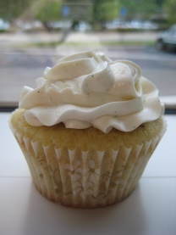
(After all, aren’t muffins just under dressed cupcakes?)
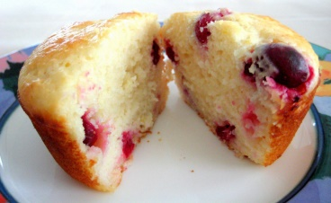
Ingredients | Amount
Betty Crocker cake mix | 1 box (432 g)
Sprite | 1 can (355 mL)

Instead of adding the water, egg and oil, simply add 1 can of sprite to the cake mix ∙
Other than that, follow the instructions on the box for mixing

How to calculate protein content
1. It has been verified by London Health Sciences with General Mills that the protein content is just the cake mix and not the added eggs. (As per their Winter 2020 Newsletter)

2. They also noted that each series of cake mix production may have different protein content listed, so it is important to look at the box each time you buy it. You may notice a box may have 1 or 2 grams of protein listed on the nutritional label. Consider this when calculating the protein, PHE and Calories!

3. CanPKU asked Retired Dietitian Valerie Austin to help us calculate the per cupcake protein if we followed the directions and made 24 equal sized cupcakes. The cake mix we were using shows 2 grams of protein in the 432g box. She used the values listed on the box of cake mix and the can of sprite, and assumed 1 gram of protein listed equals 50 mg PHE. Based on this she concluded the following;

Per total recipe: 20 g protein, 1000 mg PHE, 1840 kcal
Per cupcake (of 24): 0.8 grams protein, 42 mg PHE, 77 kcal
Per 1/12 of 2 layer cake: 1.7 grams protein, 83 mg PHE, 153 kcal
(If you should find a cake with 1 gram listed on the label, you could simply divide these numbers in half!)

Baking:

Use the cooking time on the box as a guideline only. It may take a little longer depending on the number of cupcakes or size of cake you are making. To make sure that the cake or cupcakes are done, insert a toothpick in the centre. If it comes out clean, then they are baked.
Try different flavours of pop and cakes! (Cherry Chip with Dr. Pepper maybe!)

Decorating:
∙ Use low protein options such as Cool Whip (3 tablespoons has 0.1 g protein)
∙ Decorate with sprinkles

Muffins
Remember the muffins we mentioned? Try Lemon cake mix with Dried Cranberries or make Carrot Cake into muffins! Just don’t forget to calculate any extra ingredients!

