Hayden Knox – Room/Cabin: _____

Hayden Knox’s Special Diet for:

Phenylketonuria

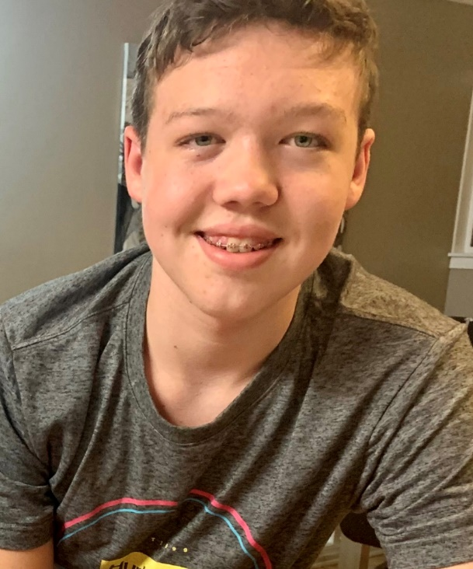 Hayden Knox is a 15 year-old boy with PKU (phenylketonuria). Hayden is allowed to eat 3 grams of protein (or 150mg Phenylalanine) per day.

Phenylalanine (or Phe) is an amino acid found in protein. It is the Phe that is toxic to his brain. Any more than 3 grams protein/day can cause brain damage.

Therefore, he must eat special low protein foods that are purchased at our local Children’s Hospital, specifically for people with PKU. **Even those low protein foods have some protein and so all foods must be carefully weighed and calculated into his diet.**

Here is a quick list of the foods Hayden **cannot** eat:

**Meat, fish, eggs, milk (anything that came from an animal), wheat/gluten, soy, Nuts, legumes, chocolate, Aspartame, and some fruits and vegetables ie. Corn.**

Hayden is very picky about how his food tastes, and can sometimes be challenging to make. We have brought some Low Protein medical foods for Hayden to eat, and the following pages explain how to cook those food items, as it is very different from mainstream foods.

Thank you for your patience and understanding -

Brienna, Hayden’s Mother.

Table of Contents:

Contents

**FAQ** 3

**Breakfast:** 4

**Low Protein Eggs** 4

**Pancakes/Waffles** 5

**Toast/Bread** 5

**FRENCH TOAST** 5

**Lunch/Dinner:** 6

**Grilled Cheese Sandwich** 6

**Cheese Quesadilla** 7

**“Meat”** 8

**Lettuce Wraps** 9

**Burger** 9

**Pasta** 10

**Vegan Imitation Shrimp Caesar Salad!** 10

# **FAQ**

**Is Cross-Contamination with “No-Foods” dangerous?**

A little bit of cross-contamination is fine as Hayden’s body needs a small amount of natural protein for growth and development. He won’t have a ‘reaction’ if he gets some natural protein. For example, he can eat fries that have been deep-fried with chicken strips. However, if a steak was grilled on a pan and there are juices etc, the pan should be washed before frying Hayden’s “food” on it.

**Is Butter or Oil safe to use when cooking?**

Yes! Oil has 0 protein. Butter has some protein, so I usually choose oil over butter when preparing a pan. However, it is okay to use Butter or Oil when preparing Hayden’s food.

**Can I use any oil?**

Yes! All oils are phe/protein free. I tend to use mostly olive oil as that is what we use at home. But vegetable oil or canola oil is fine. It is fine to put butter/margarine on his toast.

**Is it okay to use seasonings or spices?**

Yes! Most seasonings/spices are either Phe/Protein free or have very little. Fries are often seasoned with salt, parsley etc. those things are okay. However, Fries that are battered in wheat or covered in gravy are not okay for Hayden. Spices such as cinnamon, ginger, etc are all 0 protein. Mustard comes from mustard SEED so that is higher protein, and Soy Sauce comes from soya so it is also quite high protein. Hayden can have these things, but in very small quantities.

***Safe Seasonings/spices:***

Ketchup, Mayo, salt/pepper, seasoning salt, parsley etc, cinnamon, ginger etc,

***Higher Phe Spices (use in small quantities):***

Soy Sauce, Mustard, NO Parmesan cheese

**How do you get in touch if you have a question?**

You can email me (Brienna) at: _________________

# **Breakfast:**

## **Low Protein Eggs**

Hayden’s imitation eggs can be served as a flat patty style or ‘scrambled’.

**Directions:**

1.) Measure out ½ Cup Country Sunrise Imitation Scrambled Egg Mix.

2.) Add 1 Tbl Oil

3.) Add ½ Cup Water

4.) Salt (I often just add a dash while it’s on the pan cooking).

5.) Whisk together until smooth. *There are natural dyes added for colour, if you see a red or orange colour streaking, just mix it in.*

6.) Add cooking spray (or SMALL amount of oil) to frying pan and cook on medium-low until no longer “raw” inside. You can chop it up with a spatula while cooking to make scrambled eggs, or just plop it on the pan and squish it down with your spatula and keep flipping it like a pancake.

7.) Do NOT brown it if at all possible. He’s a picky kid. So cook on low if your pan cooks fast.

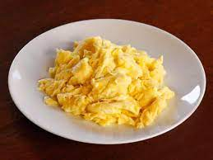

## **Pancakes/Waffles**

Hayden’s Waffles and Pancakes are very easy to make. Just add water! You want the consistency to be **thicker** than ‘regular’ pancake mix.

**Directions:**

1.) Add ¾ Cup MixQuick pancake mix to a bowl

2.) Add ½ Cup Water and whisk until smooth. Add more if its too thick for your liking.

3.) Use batter as you would to make Waffles or Pancakes.

Butter/margarine and Syrup are okay for Hayden to have.

## **Toast/Bread**

Hayden’s bread won’t toast as quickly as ‘regular’ bread. However, he also won’t eat it if it’s “dark” – or in his mind, ‘burnt’. I know it’s ready when it pops out of the toaster and it’s *just starting* to brown.

* Butter is okay for his toast.
* Please serve with Cinnamon/Sugar Mixture if available.

**FRENCH TOAST:** Water down some of Hayden’s low protein EGG MIX and coat the bread in that, then fry it in a pan like you would with regular French Toast.

# **Lunch/Dinner:**

## **Grilled Cheese Sandwich and SIDE:**

Side: Caesar Salad, OR Veggies and Ranch ie. Cucumbers, Carrots, Broccoli, Cauliflower, Peppers etc

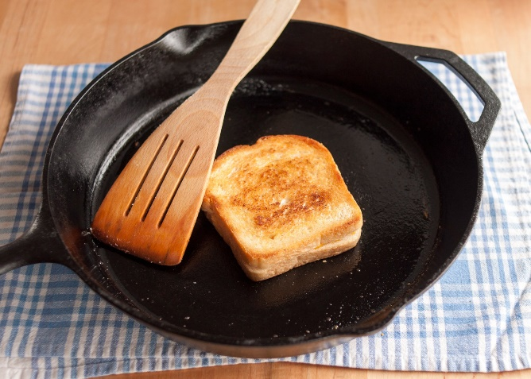

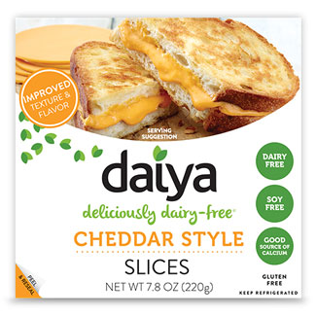

Butter/Margarine on either side of Homestyle Low Protein Bread, Place one slice of low protein Daiya Cheddar Cheese between slices of bread and place on a pan. Cover and cook for 3-5 mins on either side.

**Please serve with either:**

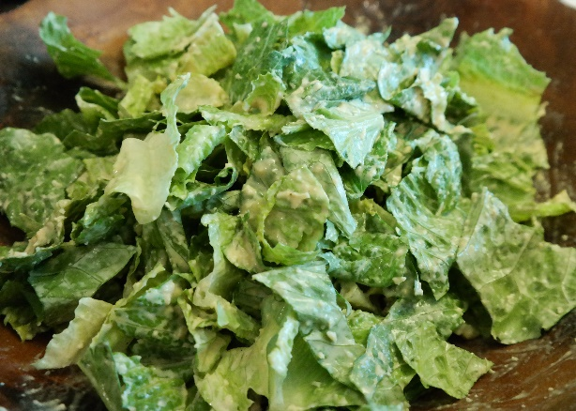**Serve with Caesar salad**

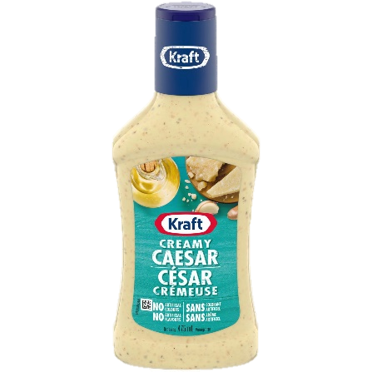Just:

* Romaine lettuce and
* Supplied Caesar dressing *(not homemade as it usually has milk, cream, eggs etc)*

**** NO parmesan cheese or croutons.

**or Veggies and Ranch Dip:**

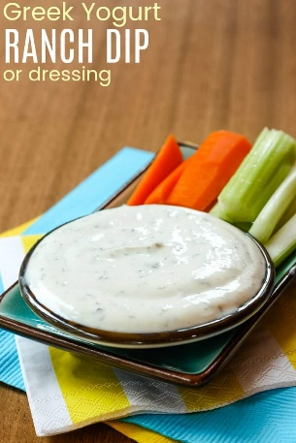 Cucumber, Carrots, Celery, Cauliflower, Broccoli, Peppers etc.

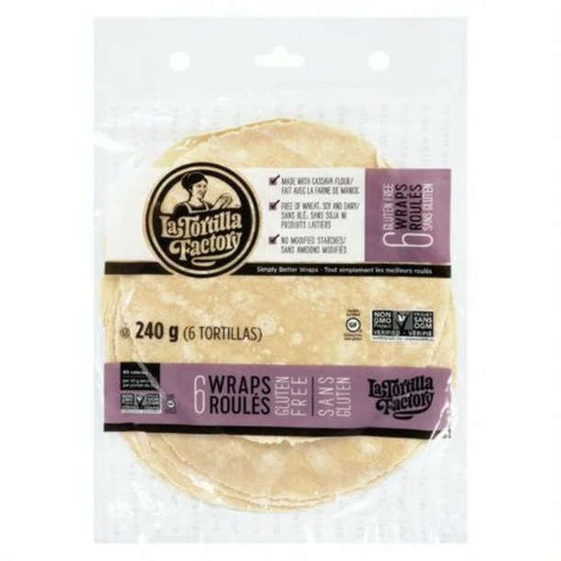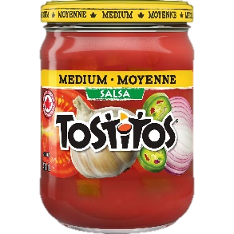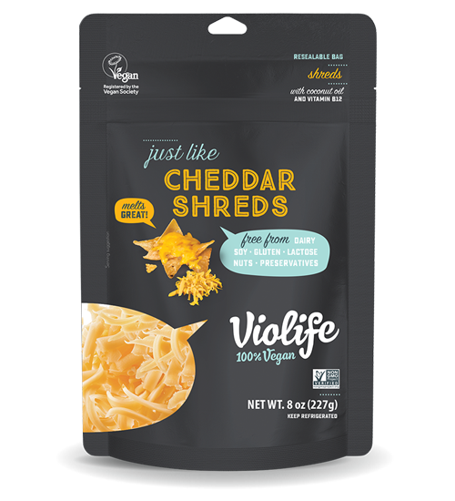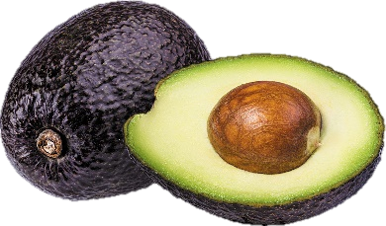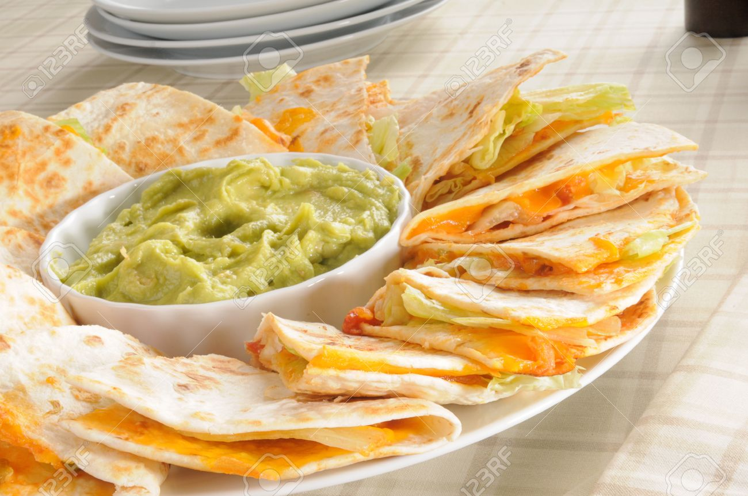

**Cheese Quesadilla (with Avacado/Salsa to dip) and SIDE: Side: Caesar Salad, OR Veggies and Ranch ie. Cucumbers, Carrots, Broccoli, Cauliflower, Peppers etc**

Please use **2 of the Gluten Free LaTortilla Factory tortillas** and the **Violife or DAIYA shredded cheese** to make a Cheese Quesadilla. They are quite small, so please lay one tortilla on the pan, spread some cheese (does not need to be weighed or measured) on tortilla, then place a second tortilla on the cheese and cover, flip after a couple of mins.

Slice into 8 triangles.

If possible – Mash an **avocado** and put that on the side to dip quesadilla in. If you have **salsa**, that would be great too. Thank you!

**Please serve with either:**

**Serve with Caesar salad**

Just:

* Romaine lettuce and
* Supplied Caesar dressing *(not homemade as it usually has milk, cream, eggs etc)*

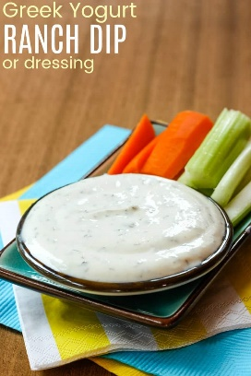**** NO parmesan cheese or croutons.

**or Veggies and Ranch Dip:**

Cucumber, Carrots, Celery, Cauliflower, Broccoli, Peppers etc.

## **“Meat”**

Hayden’s ‘meat’ is a staple for him. We make Burgers, Lettuce Wraps, Bacon etc out of his “meat”. However, being the picky kid that he is, he does not like the Chicken Patty Mix, or the Hot dog mix alone, but he DOES eat his meat as a combination of both the Chicken patty mix and the Hot dog mixed together. See below for directions.

**\*\*Tip: Since both bags are the same volume, you can just combine them into a clean, sealable bucket or Tupperware container and mix well, then scoop ¼ cup out at a time. This is what I do at home and label it “Meat”.\*\***

**Directions if using from individual bags:**

1. Combine:
   * 2 tbl (25 gr) Country Sunrise (C.S.) Chicken Pattie Mix and
   * 2 tbl (25gr) C.S. Hot Dog mix - mix together. *If you find green balls in the mix, just break them and add them in – they are added for flavour and colour.*
   * 1 tbl Oil
   * 2 tbl water.
2. Mix well. If appears too dry, add ½ tbl more water.
3. You can shape the ‘dough’ into whatever shape you need for the dish you are preparing.

**Directions if using ‘combined meats’ (both ingredients already combined in a container)**

1.) Combine:

* ¼ cup (50gr) “Mixed Meat”
* 1 tbl Oil
* 2 tbl water.

1. Mix well. If appears too dry, add ½ tbl more water.
2. You can shape the ‘dough’ into whatever shape you need for the dish you are preparing.

**SEE DETAILS NEXT PAGE ON WHAT TO MAKE WITH MEAT 🡪**

### **Lettuce Wraps:**

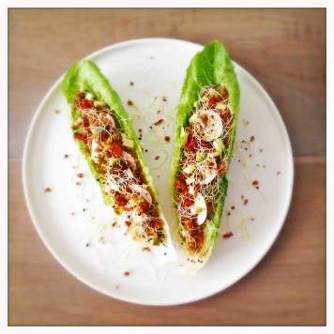**You will need:**

* Low Protein “Meat” (see last page)
* Romaine Lettuce
* Avocado (mashed)
* Salsa (if available)
* Low Protein Cheese (Violife – supplied vegan dairy free cheese)

Note**: If you do not have avocado or salsa**, you can mix ketchup and mayo together and use that as a sauce.

1. Shape Meat into a 1cm (1/3 inch) flat patty (like a PANCAKE) - fry with oil on medium heat until cooked through, approx. 3 mins per side. *Note: this meat can be used as a ‘pate’ so do not worry if you think it is ‘raw’ inside.*

2. Slice Meat into long strips (approx. 5-7 strips).

3. Lay out (approx.) 5 Full leaves of Romaine Lettuce on a plate.

4. Mash an **avocado** really well and spread along the stems of Romaine Lettuce

4. Take 3-5 Romaine leaves (depending on how big they are) and spread ketchup/mayo mix down the center of each leaf.

5. Lay a strip of “meat” on each romaine leaf, ripping pieces of meat to make them fit.

6. Sprinkle some Violife Cheese (shredded low protein cheese) onto the lettuce wraps and serve!

### **C:\Users\youb4\AppData\Local\Microsoft\Windows\INetCache\Content.MSO\9855E9B9.tmpBurger:**

Shape into a burger patty. Fry with some oil on medium heat. Approx. 3 mins per side. If I did not supply a Gluten Free, Low protein Bun, then use Hayden’s Bread (see Toast) for a bun. I cut off the crust or use a cookie cutter to make a circle for his ‘buns’. Use a slice of low protein Daiya Cheese. Serve with a side (Caesar Salad or Veggies and Ranch Dip)

## **Pasta**

1.) Bring water and pinch of salt to boil

2.) Add 1 Cup dry Aproten Ditalini Noodles – boil until fully cooked (not al dente). Strain and rinse with cool water. Set aside.

3.) Add 1/3 cup water to pot

4.) Add 1 ½ tbl Cambrooke Foods Shake ‘N’ Cheese sauce and whisk until combined.

5.) Cook on medium heat until sauce thickens, whisking continuously.

6.) Add cooked pasta and stir.

7.) Serve with Ketchup on the side.

## **Happy Veggie World Shrimp - 300gVegan Imitation Shrimp Caesar Salad!**

***** Keep frozen (if possible).

1. Take ½ bag of frozen shrimp and **fry in butter or margarine** in a pan. *Save rest of Shrimp for another meal.*
2. Fry for approx. 3 mins per side.
3. Serve with **Caesar Salad**

Just:

* Romaine lettuce and
* 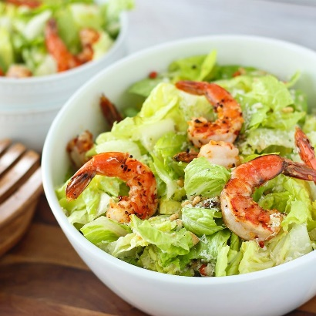****Supplied Caesar dressing *(not homemade as it usually has milk, cream, eggs etc)*

**** NO parmesan cheese or croutons.